Raymond Delgado

1. What is the database three-schema architecture?

The three-schema archticture consists of **External Schema, Conceptual Schema, and Internal Schema**. The external schema are part of the database that a specific user will interact with. The external schema consists of user views—which is a subsets of conceputal schema. The userview can be determeind from business fuction and/or data entity matrices. The database adminstoract determines the schema for the durrerent users.

The conceputal schema consists of the ERR diagram which provides a high-level descrition of infroamtioanl needs. The EER tends to only include the main compments of entity and main realtionship. It must be noted that conceputal schema are developed with software like Microsoft Viso.

The internal scheam consits of the logcal schema and physical schema. The logical shcema provides more detial than the concepeutal shcema because it is in the DBMS. The physical schama protrays how data is to represented and stored in secondary storage.

1. What is difference between DBMS and databases?

The main differerecne between a Database Mangement System is that it is a software that mange the database. Database is the storehouse of the data. The database determines how to the data is stored and organized. However, the DBMS is a software tool that is used to manage the database and the schemas.

1. What are the constraints for EER? Explain.

Here are the contstraints for an EER:

* Cardinality Constraints: The number of instances of entity that can or must be associated with each instance of another entity.
  + Minimum Carindality: If zero then it is optioanl, If one or more then it is manadotry
  + Maximum Cardianlty: The maximum number
* Comletness Constraints: Whether an instance of a supertype must also be a member of at least one subtype
  + Total Specialization Rule: Yes (double line)
  + Partial Specialziation Rule: No (Single Line)
* Disjointness Constraints: Whether an instance of a supertype may simultaneously be a member of two (or more) subtypes
  + Disjoint Rule: An instance of the supertype can be only ONE of the subtypes
  + Overlap Rule: An isntance of the supertype could be more than one of the subtypes.

1. Write the business rules based on the Book ERD below.

One publisher may or may not publish one or more books

One book must be published by one and only one publisher

One book may or may not be in one or more sales.

One sale must sell one and only one book.

One sale must be bought by one and only one customer.

One customer must buy one or more sales.

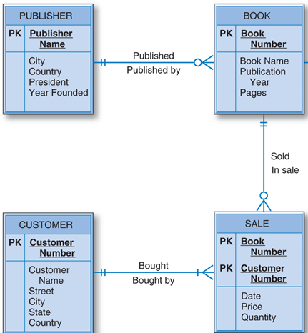

1. Database Conceptual Design

The bike company database keeps track of orders, products from warehouses. Given the following business rules, identify entity types, relationships types, keys, and then draw an ER diagram.

One order must contain one or many products.

One product may or may not be contained in many orders.

One warehouse must store one or many products.

One product must be stored in one and only one warehouse.

One product must be either a finished product or a raw product.

1) Identify entity types and relationship types. Fill out the following relationship matrix.

|  |  |  |  |
| --- | --- | --- | --- |
|  | Order | Products | Warehouse |
| Order | -- | contain | -- |
| Products | contain | May be | store |
| Warehouse | -- | Store | -- |

2) Draw an ER/EER diagram with 1) entity types, 2) relationship types, 3) keys, and 4) cardinality ratio

